# **NEA Project Analysis**

I will be making a website where you can play chess against a fairly strong engine. I researched existing projects such as VueChess, PyChess, SunFish and Python-Chess for this project. I also researched a lot of the technical things about chess engine programming on chessprogramming.org

I am making this program for regular chess players, so they can improve their skills against an engine which is suited for their level. I’m going to be working with the chess club in our school for their feedback throughout this project.

## **Objectives:**

1. All the chess pieces should behave as the rules are set
2. The user should be able to use drag and drop to move the chess pieces
3. It should be able to limit the player to only be able to move in legal positions
4. Player should be able to choose from a variety of puzzles

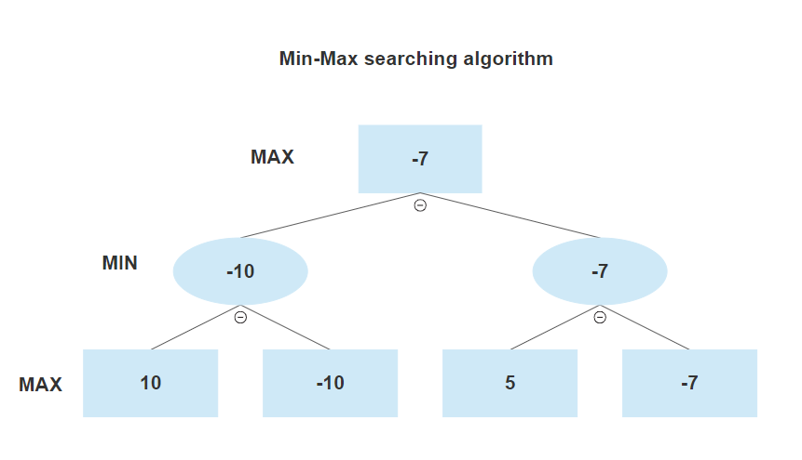

MAX – This means it is the players turn and you choose the highest value move

MIN – This means it is the opponents turn and they will choose the move which has the lowest value.

I will also be using the alpha-beta pruning algorithm which is an improvement to the Min-Max algorithm.

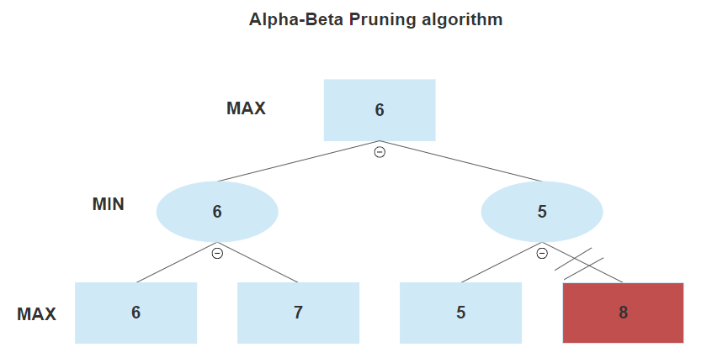

// - This means the node is not searched because there is already a higher value choice

This cuts down the amount of nodes which needs to be searched by a lot.